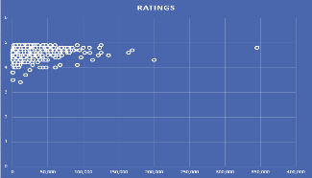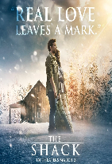A

2009 TO 2021

AMAZON TOP 100

BEST-SELLING BOOKS

Individual Ratings Given by Reader Different Years. Out of 5

Numbers of Rivew/Ratings Ratio

From 2009 to 2021, Amazon's Top 100 Bestselling Books saw dominance from fiction, especially thrillers, mystery, and fantasy. Young adult dystopian and romance also thrived. Non-fiction, including memoirs and self-help, was highly popular, along with cookbooks, romance novels, and science fiction, reflecting shifting reader preferences.

The Most Popular Genres Based on The Number of Reviews

Between 2009 and 2021, Amazon's Top 100 Bestselling Books reflected changing reading trends, with fiction dominating—particularly young adult dystopian novels like *The Hunger Games* and *Divergent*. Psychological thrillers, such as *Gone Girl* and *The Girl on the Train*, also became hugely popular. Non-fiction books like *Becoming* by Michelle Obama resonated with readers seeking self-improvement and personal stories. Cookbooks, biographies, and business books were consistent bestsellers, while e-books and audiobooks gained popularity, expanding the reach of self-published authors and reshaping the publishing landscape.